Patrice Moracchini
CSD430-308A(2267-DD)
July 5th, 2026

Working with CRUD-READ, JDBC & JavaBeans - Project Part 1
Module 5.3 and 6.3 Assignment
Pr. Payne

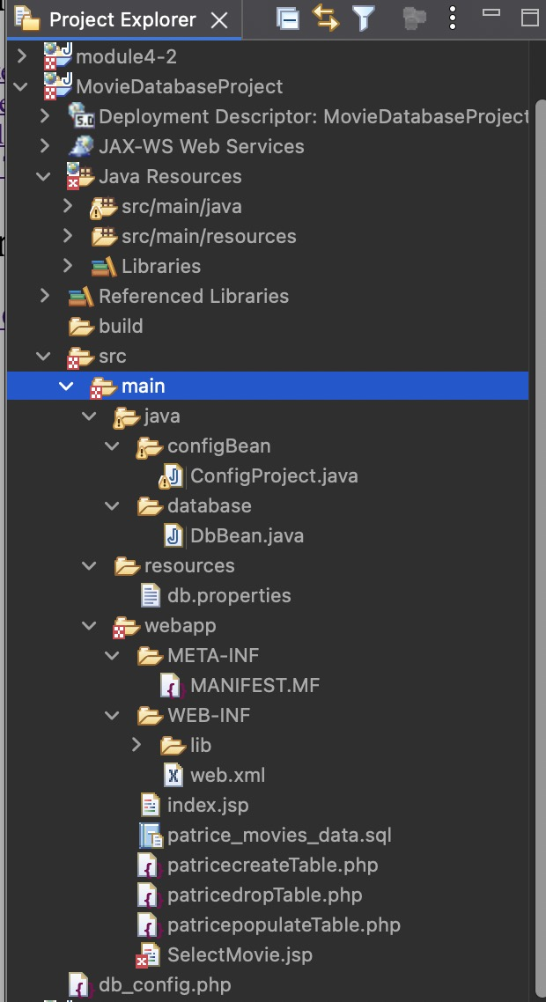
Eclipse Project Tree Screenshot

index.jsp Screenshot

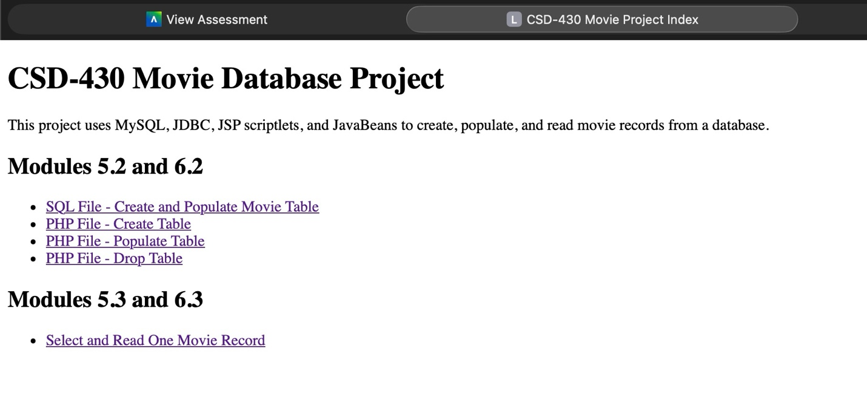

selectmovie.jsp Before Submitting
Screenshot

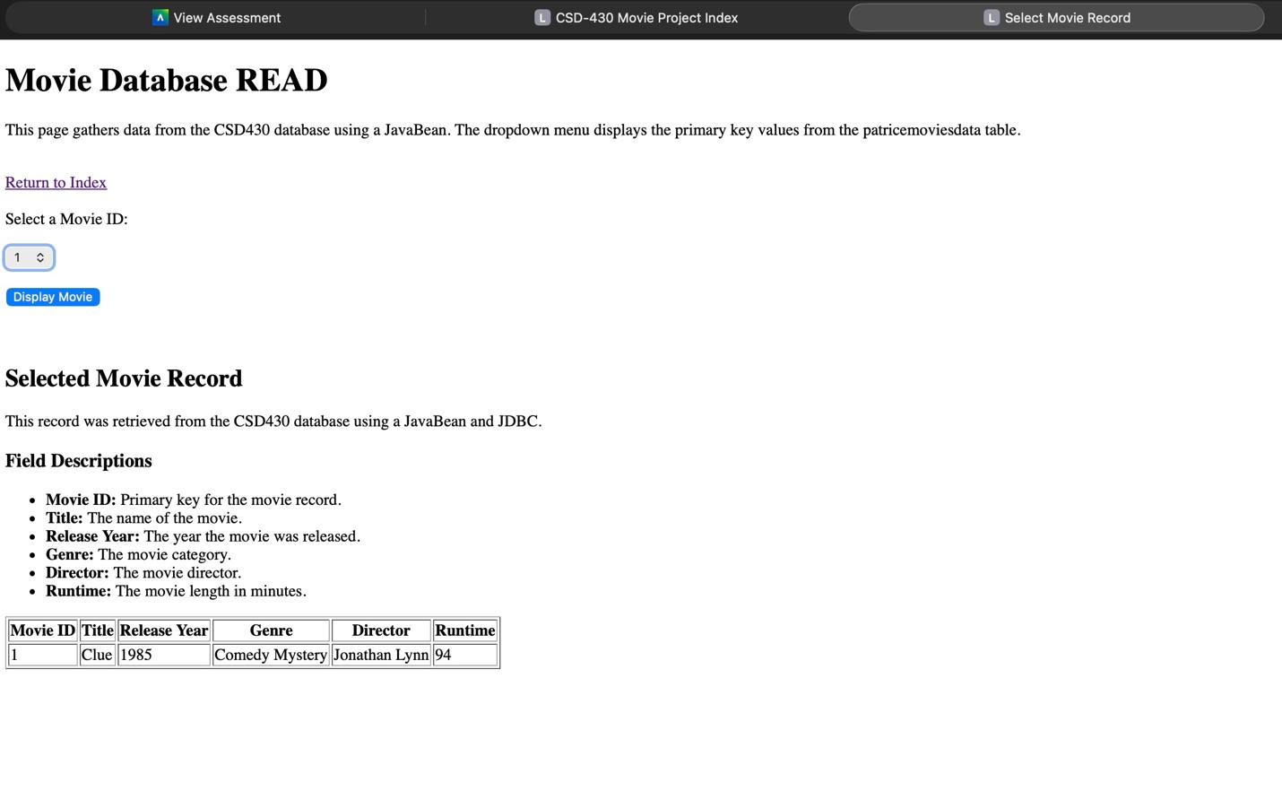

selectMovie.jsp After Submitting
Screenshot
